Data Masking:

|  |  |  |  |  |  |  |
| --- | --- | --- | --- | --- | --- | --- |
| Employee ID | Name | User ID | Gender | Age | Phone Number | Date of Birth |
| 57861 | Ralph Kendrick | dem55 | O | 35 | 7758956347 | 20-05-1988 |
| 18953 | Dorothy Leadbetter | har83 | M | 20 | 9150357745 | 07-07-2003 |
| 33291 | Greg Rm | kja96 | F | 18 | 7865489007 | 04-10-2005 |
| 96272 | Craig King | jsm77 | F | 44 | 9374674890 | 16-08-1979 |
| 7195 | Linda Behan | pnx31 | M | 65 | 7689988542 | 29-09-1958 |
| 94757 | Liane Lavin | jdb81 | F | 43 | 9347897140 | 08-07-1980 |
| 48167 | Mary James | bwg34 | O | 57 | 9445678912 | 13-04-1966 |
| 50730 | Kenneth Bass | fsk57 | F | 45 | 9946771966 | 28-02-1978 |
| 46122 | Matthew Lara | rdv50 | M | 28 | 9994034782 | 25-03-1995 |
| 78912 | Greig Smith | grs10 | O | 32 | 9387361103 | 01-01-1991 |

|  |  |  |  |
| --- | --- | --- | --- |
| Driver's License Number | Passport Number | Bank Account Number | Email address |
| US2320217789012 | A3903463 | 15432964088 | [kend634@gmail.com](mailto:kend634@gmail.com) |
| US1420201474654 | B5238914 | 11653894257 | [lead774@gmail.cmm](mailto:lead774@gmail.cmm) |
| US8520228548916 | P8539510 | 12546729086 | [graig634@gmail.com](mailto:graig634@gmail.com) |
| US3420211174590 | A8239058 | 26789259789 | [king489@gmail.cfm](mailto:king489@gmail.cfm) |
| US2120213382901 | U6452890 | 85372897256 | [behn854@gmail.cmm](mailto:behn854@gmail.cmm) |
| US9020226739034 | N6349025 | 67387098734 | [lavi714@gmail.cfm](mailto:lavi714@gmail.cfm) |
| US1120194590763 | S7450928 | 52890156238 | [jame891@gmail.com](mailto:jame891@gmail.com) |
| US2720237320165 | P6428904 | 62296086118 | [bass196@gmail.cfm](mailto:bass196@gmail.cfm) |
| US3420212890123 | C6328942 | 45396802167 | [lara478@gmail.cmm](mailto:lara478@gmail.cmm) |
| US2720196219054 | F7501358 | 16724390568 | [smit110@gmail.com](mailto:smit110@gmail.com) |

|  |  |  |  |
| --- | --- | --- | --- |
| Weight | D.NO | Street name | Pin code |
| 89.74 | c-20 | Park Avenue | 625016 |
| 56.56 | E-85 | Washing Tone Street | 624902 |
| 66.5 | S-60 | Crosby Street | 623917 |
| 94.69 | W-30 | Fifth Avenue Street | 623908 |
| 70.86 | D-9 | Broadway | 536894 |
| 80.78 | F-8 | St Mark's | 456789 |
| 61.65 | G-9 | Madison Avenue | 345678 |
| 70.74 | C-22 | NYC street | 536478 |
| 50.67 | D-59 | Jones Street | 657383 |
| 68.39 | R-20 | Walls Street | 643589 |

*The above data which we are working on contains all the data types for performing data masking.

Algorithms for bank account number / phone number

1.Creating a list for each number and randomly assigning the numbers

* 123 - 1
* 456 - 2
* 789 - 3
* 012 - 4 12345678 – 25814705,14703691,36925810
* 345 - 5
* 678 – 6
* 901 - 7
* 150 – 8

2. Using Least Common Multiple

* 12345678 – 64696902 (Need to find the LCM for the number and multiple the numbers)

12345678 = 2 x 3 x 3 x 47 x 14593 = 64696902

3. Using Prime factorisation by splitting the numbers

* + - * 12345678 - 1357 and 2468(Write each number as a product of its prime factor)
      * For 2468
* 2 = 2
* 4 = 2^2
* 6 = 2 * 3
* 8 = 2^3

LCM (2, 4, 6, 8) = 2^3 * 3 = 24

* + - * For 1357

• 1 = 1

• 3 = 3

• 5 = 5

• 7 = 7

LCM (1, 3, 5, 7) = 1 * 3 * 5 * 7 = 105

* + The final number will be 24105.

4. Multiply the numbers individually and assigning even numbers as odd numbers and vice versa

* + - * 1*2*3*4*5*6*7*8 – 40320
* The final number will be 75015.

5.  Rounding up the numbers and later shuffling the indexes

* 12345678 -    12347000 - 04210037
* 12345678 -    12345680 - 82541603
* 12345678 -    12346000 - 30021640

6. Randomly adding the consecutive numbers

* (1+2) (3+4) (5+6) (7+8) -     371115
* (1+2+3+4) (5+6+7+8) -     1026

7. shorten the number and giving the binary code for the rest of the indexes

* + 12345678 -     3456 0101
  + 12345678 -     1278 1001

8. Fixing threshold and assigning characters

* 12345678 - 00001111 (assigning 0 for <5, 1for >5)
* 12345678 – xxxxzzzz (assigning x for <5, z for >5)

9.  Multiple with random number then subtracting with original number

* 12345678 - (12345678 * r) - 12345678

10.  Keep the first 3 integers and reverse the next 2 integers and mask the balance integers with asterisk (*).

* + - * 12345678 – 12354***

11. Divide the integers equally and swap it.

* 12345678 – 56781234

12. Add, subtract the integer with the fixed value

* 12345678 + (64312587) = 76658265
* 12345678 – (64312587) = 51966909

13. XOR the integer with the random number

* 12345678 - 444C

14. Convert the integer to a string and replace each digit with the random digit.

15. XOR the integer with the result of a bitwise AND operation with a random value

|  |  |
| --- | --- |
| Result in binary | 10000000010 |
| Result in decimal | 1026 |
| Result in hexadecimal | 402 |

16. XOR the integer with the result of a bitwise OR operation with a random value.

|  |  |
| --- | --- |
| Result in binary | 1011011111110 |
| Result in decimal | 5886 |
| Result in hexadecimal | 16fe |

17. Add the integer to a random power of 2 by splitting the numbers.

* Xn =212= =4096
* 21234 = 2.958112246 E+371

18. Raise a randomly generated integer to a random power and then multiply the result with the original integer.

xn=214=214=16384 * 12345678 = 202271588352

19. Permute the bits of the original integer according to a randomly generated permutation which generates the possible ways.

* The number of combinations possible with 8 numbers is 255.

20. Perform a randomly selected bitwise operation on the original integer.

Algorithm for Driver licence / User ID / Passport number

1. Hashing method

* US12345678 - **938c2cc0dcc05f2b68c4287040cfcf71**

2. Hiding the strings or numbers

* USA1234 - ***1234
* USA1234 – USA****

3. Substituting numbers as strings and vice versa

* USA1234 – 678AJDB

4. bloom filter algorithm

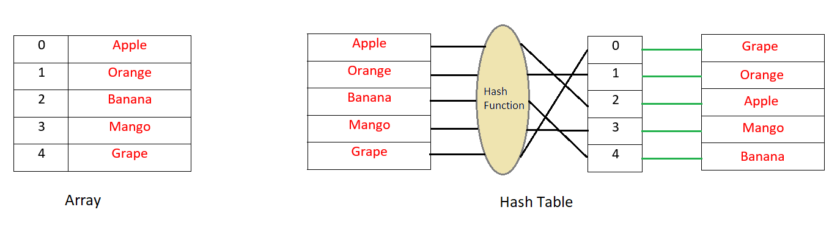

U - 0 - A

S - 1 - 6

A - 2 - 8

1 - 3 - 9

2 - 4 - T

3 - 5 - O

4 - 6 - 3

5. Convert the integer to a string and replace each digit with the random from a predefined character set. (Importing the predefined set like ASCII or hexadecimal)

6. Add a random string to the integer and take the modulus with a larger prime number.

* 12345678 - 949667R7

Divide *a by b* to find the remainder.  
  
12345678 ÷ 13 = 949667 R7  
  
Confirm the answer satisfies the equation:  
  
Quotient × Divisor + Remainder = Dividend  
  
949667 × 13 + 7 = 12345678

7. Convert using hexadecimal.

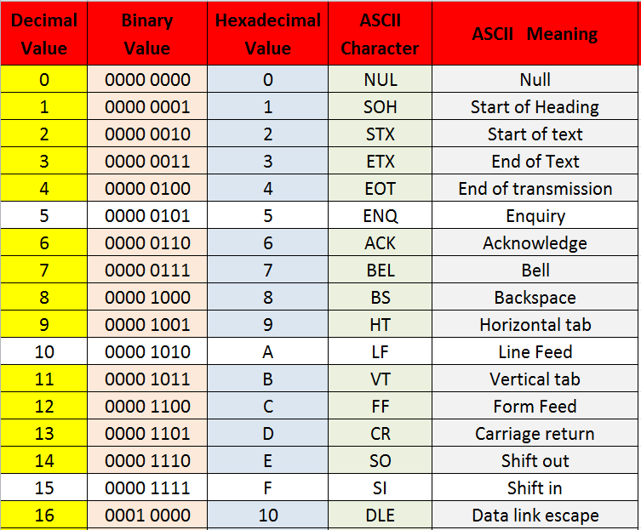

8. Fisher–Yates shuffle Algorithm

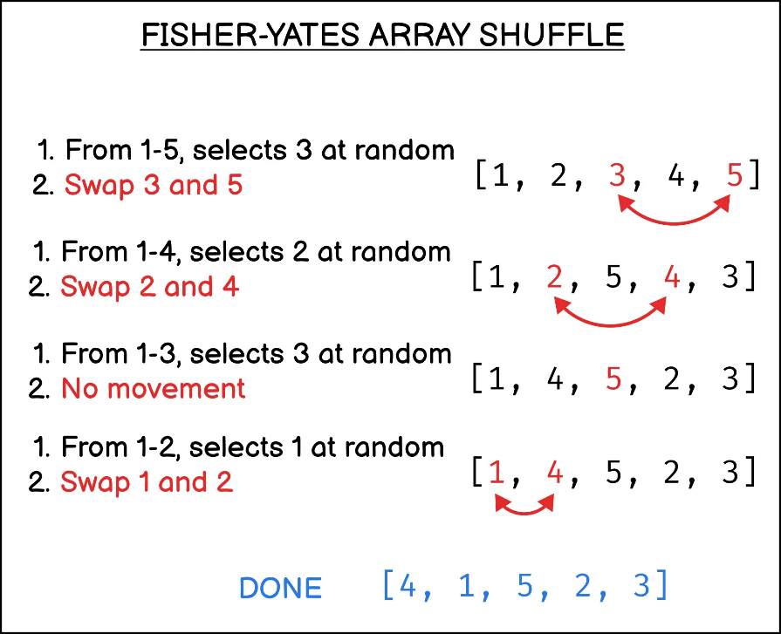

9. Have a threshold for half value for both number and alphabet, then replicate the opposite value.

* ABCD1234 - ZYXW9876

10. mask the string characters and multiply the numbers individually and add zeros for the rest of the indexes

* AFD12345 - ###12000